Wessex Medical Research (WMR) invites bids for grants from its Innovation Fund.

Five grants, each of up to £20,000, are available

The Innovation Fund aims to pump-prime innovative medical research by early career researchers at the University of Southampton. The grants are intended to provide funding to the researcher to undertake original work with the objective of launching their research career. It is expected that the application will be mainly or wholly for the cost of consumables and related activities: funding will not be provided for fees, stipend or travel costs other than those necessarily incidental to the research itself, nor will grants be made to top up funding sought elsewhere. A contribution to salary will be considered only if the applicant is not in a University-funded salaried post.
Applicants must be a maximum of 10 years post award of PhD or DM, exclusive of career breaks or less than full-time working, details of which should be provided in the relevant section of the application form. Applications will not be accepted from Associate Professor / Principal Research Fellow staff (level 6 or equivalent) or above. Applicants who have previously received an Innovation Grant are disqualified.
Grants will extend for a period of two years at the conclusion of which the recipient will be expected to submit a report/paper on the results: due recognition must be given to the involvement of WMR. The Applicant must complete the attached application form: please adhere to all the stated word or character limits. The final page of the application form can be used for graphs, charts or pictures: any further attachments will be disregarded.
The Applicant must arrange for the relevant Associate Dean for Research (or their nominee) to confirm compliance of the project with their Faculty’s research programme in an email sent to peter.dawes@wesmed.org.uk;
Where relevant, the Applicant must confirm that the NHS National Data opt-out Programme will be adhered to.
It is essential that the Applicant confirms that the University’s policies on ethics and the treatment of animals (where relevant) will be strictly adhered to. If no animals are to be involved in the Project, this must be clearly stated in the ‘Ethical Approval’ section of the form. As a member of the Association of Medical Research Charities (“AMRC”), WMR supports the AMRC’s statement on the use of animals in research. For details please see: https://www.amrc.org.uk/position-statement-on-the-use-of-animals-in-research
Applications must be submitted by email to: peter.dawes@wesmed.org.uk
to arrive by noon on Friday 14 February 2025. Late applications will not be accepted.

All applications will be acknowledged and all applicants will be notified of the outcome by the end of May 2025 at the latest.

Our Data Protection Policy is available at www.wesmed.org.uk.

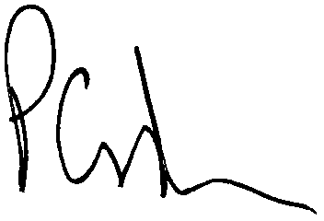
P G Dawes 2 January 2025
Trust Director

